Electricity I: Static electricity and Capacitance

Remember to photocopy 4 pages onto one sheet by going A3→A4 AND back to back on the photocopier

Student name: ________________________________

This booklet contains every higher and ordinary level question that has appeared on an exam paper on this topic from 2002–2023
Worked solutions to Ordinary Level Maths questions can be found at the end of the booklet.
Fully worked solutions to all higher level past papers can be found on the homepage of thephysicsteacher.ie

Screencasts of all topics plus a wide range of other resources via this link

You can find this document plus all other booklets on the homepage of thephysicsteacher.ie
Last updated: 04/08/2024
Noel Cunningham
Contents
1: STATIC ELECTRICITY 3
Something to think about 3
Student Notes 3
Charge 3
The gold leaf electroscope (GLE) 4
Charging a conducting object by induction 4
Earthing 4
Coulomb’s Law 5
Electric fields 6
Direction of electric field lines 6
Electric field patterns 6
To demonstrate electric field patterns 7
Exam questions: Electric fields 8
Electric field strength 9
Electric field strength a distance ‘d’ from the surface of a charged sphere 10
Distribution of charge on an insulated conductor 11
1. All static charge resides on the outside of a conductor 11
2. Charge density on a conductor is greatest where the conductor is most pointed 11
Point discharge 12
Demonstrating point discharge 12
Applications of electric fields 12
Industrial hazards 12
Background reading 13
SLOP 17
Static electricity Exam Questions 2022 - 2002 20
Gold leaf electroscope: Ordinary Level 20
Gold leaf electroscope: Higher level 21
Electric fields / Electric field strength Ordinary level 22
Electric fields / Electric field strength Higher level 22
Electric field strength a distance ‘d’ from the surface of a charged sphere 24
The Millikan oil drop experiment 25
General questions 26
2: POTENTIAL DIFFERENCE 27
Student notes 27
Potential difference 27
The volt 27
Relationship between work, charge and potential difference 27
Potential at a point 27
3: CAPACITANCE 28
Student notes 28
Capacitors 28
The parallel plate capacitor 30
Relative permittivity ε_{r} 31
To demonstrate the factors affecting the capacitance of a parallel plate capacitor 31
31
To show that a charged capacitor stores energy 32
The energy stored in a capacitor 32
Common applications of capacitors 33
Review of some electrical symbols and units 34
SLOP 35
Capacitance Exam Questions 2022 – 2002 36
Capacitance Ordinary Level 36
Capacitance Higher level 38
More challenging questions 40
SOLUTIONS TO ORD. LEVEL EXAM QUESTIONS (MATHS PARTS ONLY) 2022 - 2002 41

1: STATIC ELECTRICITY

Something to think about

- Electrons are negatively charged, protons are positively charged and opposite charges attract. So why don’t the electrons ‘fall’ into the nucleus? Why do lots of similarly-charged protons co-exist peacefully in the nucleus?
- Why is it that socks which are dried in a tumble-dryer come out lovely and soft while those which are dried on a clothesline outside are often hard/abrasive?
- Why is (uncharged) paper attracted to a charged balloon?
- Why is a car antenna always on the outside of the car?

- “If dreams were lightning, and thunder were desire
This old house would have burnt down a long time ago.”
Angel From Montgomery - John Prine. As good an excuse as any to get a line from a John Prine song into a set of physics notes. But what causes lightning?

Student Notes

Charge
If an object has more electrons than protons it is negatively charged, if the object has more protons that electrons then it is positively charged).

Opposite charges attract; similar charges repel each other.

You can demonstrate this by hanging two oppositely charged rods as shown and note that they both move towards each other. If were to hang two similarly-charged rods near each other they would repel each other.

2023 Deferred Higher Level  Explain why a balloon that has been rubbed vigorously on a woolly jumper can stick to a wall. | The balloon becomes charged by friction.  Like charges in the wall are repelled and so the balloon sticks to unlike charges left closest to the surface of the wall.

The symbol for charge is Q (from quantity of charge)
The unit of charge is the coulomb – the symbol for the coulomb is C.

So for example an electron has a charge of 1.6 × 10⁻¹⁹ coulombs .
The coulomb is the amount of charge that passes when a current of one amp flows for one second.

Earthing

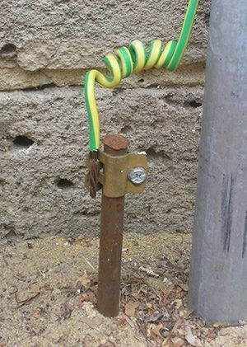

If an object becomes charged (due to a build-up of electrons say), and the object is then ‘earthed’ (connected to earth), the electrons will separate as much as possible, resulting in most of them quite literally ‘going to earth’.
The object then becomes neutral.
Your home probably has a pole connecting the earth wire in your house directly to the ground.

John Travoltage
https://phet.colorado.edu

The gold leaf electroscope (GLE)

You must know the structure of an electroscope and list some of its functions.

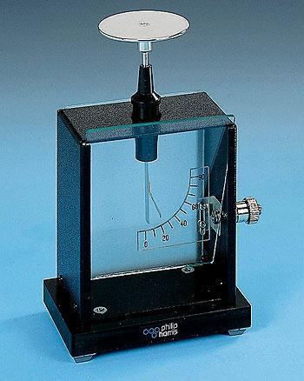
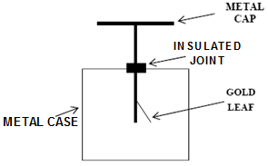

- If the GLE is uncharged, the leaves will fall together.
- If the leaves become charged – either positively or negatively – the leaves will stand apart (why?).
- The earth connection on the right hand side ensures that there is no excess charge on the wall of the electroscope (which could attract or repel the gold leaf, reducing the leaf’s ability to rise if the GLE is charged).

Functions of the gold leaf electroscope
- To detect charge
- To distinguish between positive and negative charge
Can you explain how the GLE could be used to carry out each of these functions?

Charging a conducting object by induction

To charge an insulated conductor positively
For illustration purposes we will choose a gold leaf electroscope as our object

Negatively-charged rod is brought near the cap | Electroscope is earthed | Remove the earth connection | Remove the rod
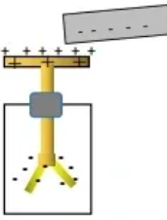 | 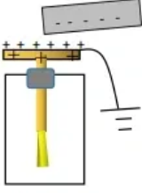 | 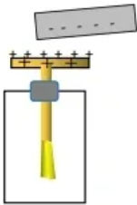 | 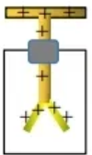

- Bring a negatively charge rod close to but not touching the conductor (the positive and negative charges become separated on the conductor).
- Keeping the charged object in place, earth the conductor by connecting an earth wire or simply touching it with your finger {some of the negative charge on the metal flows through you to earth}.
- Remove your finger, then (and only then) . . .
- remove the rod
The conductor is now positively charged

You should now also be able to list the procedure necessary to charge an object negatively by induction and note also that the same process applies to charging any isolated conductor – see image on the right.

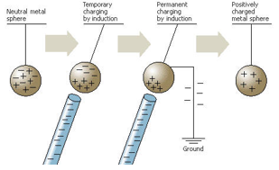
Summary – 4 points which you must include in your answer
- Bring charged rod close to (but not touching) insulated conductor.
- Earth electroscope
- Remove earth (while rod is close)
- Remove rod

Coulomb’s Law

Coulomb’s Law states that the force between two point charges is proportional to the product of the charges and inversely proportional to the square of the distance between them.

Mathematically: F ∝ (Q₁ Q₂)

And F ∝ 1 / d²
F =
Putting this together where the proportional constant is

ε (epsilon) is known as “the permittivity” of the medium {it represents the extent to which one charge will be affected by another, e.g. glass has a different permittivity value than air}
(ε₀ = 8.9 × 10⁻¹² F m⁻¹)

2013 Question 12 (c) [Higher Level]  Calculate the force of repulsion between two small spheres when they are held 8 cm apart in a vacuum (each sphere has a positive charge of 3 μC).  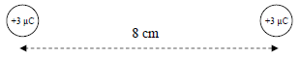  3 μC = 3 × 10⁻⁶ C | d = 8 cm = 0.08 m  Q₁ = Q₂ = 3 × 10⁻⁶ C  F =  F = $\frac{1}{(4)(π{)(8.9×10}^{-12})}\frac{{(3×10}^{-6})({3×10}^{-6})}{0{.08}^{2}}$  F = 12.57 N
2005 Question 10 [Higher Level]  A charge of 5 μC is placed at point B, which is 10 mm from an electron.  Calculate the electrostatic force exerted on this charge. | d = 10 mm = 0.01 m  Q₁ = 5 × 10⁻⁶ C  Q₂ = 1.6 × 10⁻¹⁹ C  F =  F = $\frac{1}{(4)(π{)(8.9×10}^{-12})}\frac{{(5×10}^{-6})({1.6×10}^{-19})}{0{.01}^{2}}$  F = 7.2 × 10⁻¹¹ N towards the electron
2012 Question 8 [Higher Level]  Calculate the force of repulsion between a deuterium and a tritium nucleus when they are 2 nm apart in free space.  Note that the nuclei of deuterium and tritium both have just one proton (although deuterium has 1 neutron and tritium and 2 neutrons this doesn’t affect the charge).  The charge on a proton is the same as the charge on an electron: 1.602 ×10⁻¹⁹ C  (ε₀ = 8.854 × 10⁻¹² F m⁻¹) | $$F= \frac{q_{1}q_{2}}{4πεd^{2}}$$  $$F= \frac{{{(1.602×10}^{-19})}^{2}}{4π{(8.854 ×10}^{-12}{)(2×{10}^{-9})}^{2}}$$  F = 5.77 × 10⁻¹¹ N
Calculate the electrostatic force of repulsion between two protons separated by 10^{–10} m (a typical inter-atomic distance).  Calculate the gravitational force of attraction between them. | Answer:  Electrostatic force: 2.3 × 10^{–8} N  Gravitational force: 1.9 × 10^{–44} N.

Electric fields

An electric field is a region of space where an electric charge experiences an electrostatic force.

All charged objects create an electric field that extends outward into the space that surrounds it. This electric field will have an effect on any other charged object that enters the field.

Electric field patterns
The convention is that electric field lines come out of a positive charge and into a negative charge.

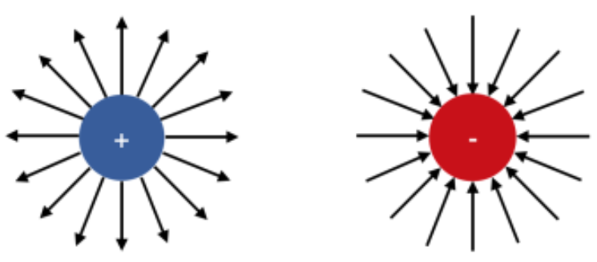
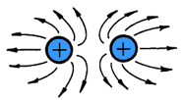 | 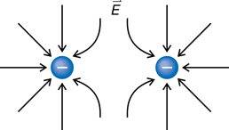
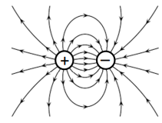 | 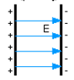

2019 Question 7  Draw the electric field around a positively charged sphere | 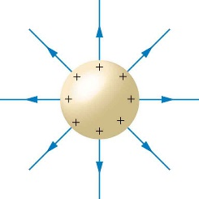
2013 Question 12 (c) [Higher Level]  Copy the diagram and show on it the electric field generated by the charges. | Curved deviation of the field lines needs to be clearly evident  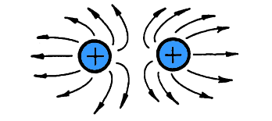

To demonstrate electric field patterns

2020 Question 7 [Ordinary level]
Describe, with the aid of a labelled diagram, an experiment to show an electric field pattern.
On your diagram, show the electric field, including its direction.

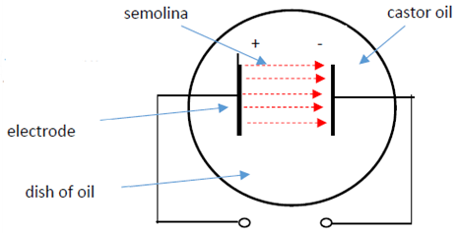
Procedure
Set up as shown. Diagram must include dish of castor oil, high voltage d.c. source, two electrodes
- Turn on the power supply.
- Sprinkle semolina powder over the electrodes.
- Observation: Semolina forms electric field pattern.

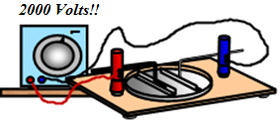
Exam tips:
- You will lose marks in an exam if you do not stress the high voltage.
- You will need to draw the circuit diagram to show how the apparatus is connected together.
- You must specify semolina or a similar powder; metal filings are for demonstrating magnetic field lines and are not acceptable for this demonstration.
Van de Graff generator
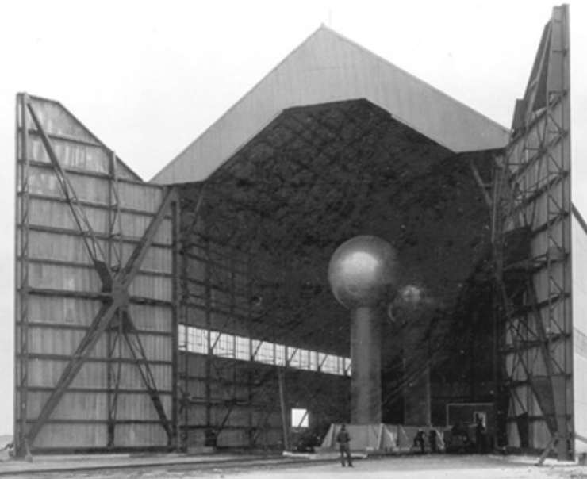
Can you spot the man at the bottom of the photo?

Electric field strength

Sometimes it’s useful to get a sense of how strong an electric field is. We do this mathematically by calculating the effect the field would have on an imaginary test charge of one coulomb.

Electric field strength (E) at a point is the force per unit charge at that point

{This is one of the most asked definitions on the syllabus}
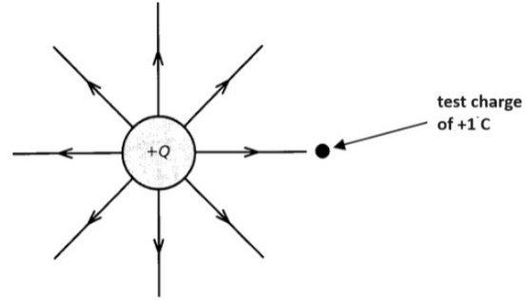
$$E=\frac{F}{Q}$$

The unit of electric field strength is the newton per coulomb (N C⁻¹).
E =
Also note that because F =

We now have two equations for electric field strength; if a distance is given in the question it means that you need to use the second equation.

2005 Question 10 [Higher Level]  Calculate the electric field strength at the point B, which is 10 mm from an electron. | $E=\frac{Q}{4πεd^{2}}$ $E=\frac{1.6 ×{10}^{-19}}{4π(8.9×{10}^{-12}){(0.01)}^{2}}$ E = 1.4 × 10⁻⁵ N C⁻¹
2017 Question 5 [Higher level]  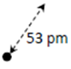  What is the electric field strength 53 pm from a proton?  Note:  1 pm (“picometre”) = 1 × 10⁻¹² m | E = E = Q/4πεd²  E = (1.6 × 10⁻¹⁹)/4π(8.9 × 10⁻¹²)(53$×{10}^{-12}$)²  $E=5.1×{10}^{11}$N C⁻¹
Point A is a 5 μC point charge while point B is a 10 μC point charge.  If the charge at point B increases to 20 μC, does the electric field at B:  - increase  - decrease  - remain unchanged | I like this question because it helps to clarify what we mean by an electric field. It is the force (in this case from the charge at A) on an imaginary (test) charge of 1 C. So it doesn’t make any difference what the actual charge of B is.  Answer: (iii)

Electric field strength a distance ‘d’ from the surface of a charged sphere

If question asks us to calculate the electric field strength at a point which is a distance d from the surface of a sphere, then the distance used in the calculation must be the distance that point and the centre of the sphere (so d + r, where r is the radius of the sphere). This is because we the charge is spread equally around all parts of the surface so mathematically we can treat the question as though all the charge was located at the certre of the sphere (similar to the centre of gravity of a sphere).

2022 Question 9 (a) [Higher level]  A metal sphere of diameter 5 cm holds a charge of –6 μC.  Calculate the electric field strength at a distance of 3 cm from the surface of the sphere. | d = (3 cm to the sphere) + (2.5 cm to the center of the sphere)  = 5.5 cm = 0.055 m  $E=\frac{Q}{4πd^{2}}$ $=\frac{6×{10}^{-6}}{(4π)(8.854×{10}^{-9})({0.055)}^{2}}$  = 1.78 × 10⁷ N C^{–1}
2015 Question 8 [Higher Level]  The spherical dome of a Van de Graaff generator has a diameter of 40 cm and a charge of 3.8 μC.  What is the electric field strength at a point 4 cm from the surface of the dome? | d = 4 + 20 = 24 cm = 0.24 m  $$E=\frac{Q}{4πd^{2}}$$  $$E=\frac{{3.8×10}^{-6}}{(4)(π{)(8.9×10}^{-12}{)({0.24)}^{2}}^{}}$$  E = 5.9 × 10⁵ N C^{–1} away from the centre of the dome
2019 Question 7 [Higher Level]  A spherical conductor has a diameter of 12 cm.  There is an electric field strength of 2.3 N C^{‐1} at a distance of 5 cm from the surface of this spherical conductor.  Calculate the charge on the conductor. | d = 11 cm = 0.11 m  $E=\frac{Q}{4πεd^{2}}$ $2.3=\frac{Q}{4π(8.9×{10}^{-12}){(0.11)}^{2}}$  Q = 3.1×10⁻¹² C
2007 Question 8 [Higher Level]  The dome of a Van de Graff generator is charged. The dome has a diameter of 30 cm and its charge is 4 C.  A 5 μC point charge is placed 7 cm from the surface of the dome.  - Calculate the electric field strength at a point 7 cm from the dome  - Calculate the electrostatic force exerted on the 5 μC point charge. | - d = 0.07 + 0.15 = 0.22 m  = 7.39 x 10¹¹ N C⁻¹  - F = Eq  F = (7.39 × 10¹¹)(5 × 10⁻⁶) F = 3.69 × 10⁶ N

Direction of electric field strength at a point

The convention is that the direction of the electric field lines at a point indicate the direction of force experienced by a test unit positive charge at that point.
This means that if the source of the electric field is a positive charge then the field lines at the test charge will point away from the source charge, and if the source of the electric field is a negative charge then the field lines at the test charge will point towards from the source chare.

2003 Question 12 (c) [Higher Level]
The diagram shows a negative charge – Q at a point X.
Copy the diagram and show on it the direction of the electric field strength at Y.

Solution:
“The electric field strength at Y” means “the force that would be exerted on a unit positive charge if it were at position Y” so to answer this question imagine that you are that positive charge at Y; what direction would you be pushed or pulled towards?}
In this case there is a negative charge at point X so if I was a positive charge at position Y I would be attracted to X (but not in a kinky way).
Answer: Draw an arrow from Y pointing towards X. 💕💕💕

2005 Question 10 [Higher Level]  What is the direction of the electric field strength at B? | Towards the electron / to the right
2013 Question 12 (c) [Higher Level]  Copy the diagram and mark a place where the electric field strength is zero | A test charge of +1 coulomb placed halfway between both charges would be equally repelled by both, so the net force on it would be zero (remember that electric field strength is defined as force per unit charge).  So mark a point halfway between the charges.

Distribution of charge on an insulated conductor

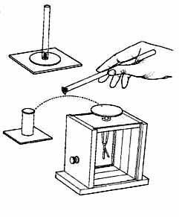
1. All static charge resides on the outside of a conductor

Demonstration
- Charge the conductor (a metal can will do fine).
- Using a proof plane, touch the inside of the can and bring it up to the GLE.
Notice that there is no deflection.
- Touch the proof plane off the outside of the can and bring it up to the GLE.
Notice that there is a deflection.
- Conclusion: charge resides on outside only

2007 Question 8 [Higher level]
All the charge resides on the surface of a Van de Graff generator’s dome. Explain why.
Answer: Like charges repel and the charges are a maximum distance apart on the outside surface of dome.

Application:
- A Van der Graff generator is used to generate a large build-up of charge which resides on the outside surface of the dome.
- A full-body metal-foil suit protects an operator when working on high voltage power lines (strictly speaking it doesn’t even have to be solid – a wire mesh would also work).

2. Charge density on a conductor is greatest where the conductor is most pointed
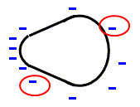

Demonstration
- Charge a pear-shaped conductor .
- Use a proof plane to bring charge from the curved end to the GLE, and note that there is a minimal deflection.
- Use a proof plane to bring charge from the pointed end to the GLE, and note that the deflection is much greater.
- Conclusion: Most of the charge is at the pointed end.

Point discharge

- On a pear-shaped conductor, most charge accumulates on the pointed end.
- If the build-up of charge is sufficiently large the repulsion between charges becomes so great that some ‘jump off’ the surface, colliding with and ionising atoms in the surrounding air.
- Ions with opposite charge are attracted towards the point and neutralise the charge on it.

Demonstrating point discharge

- Attach a nail to the surface of a working Van der Graff generator.
- Bring up a candle and notice that the flame moves away from the Van der Graff.
This is because of the ‘wind’ generated by point discharge.

Applications of electric fields
- Precipitators (used to extract smoke particles from the air).
- Photocopier machines

Industrial hazards
- Explosion in flour-mills or when fuelling aircraft
- Damage to integrated circuits.
- Electric shock

You are also expected to know a little about lightning and lightning conductors. See below.

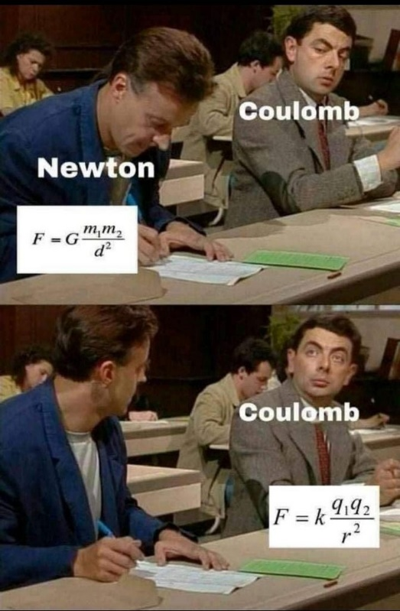
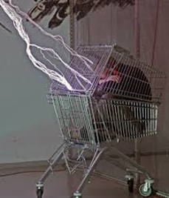

Background reading

Demonstrating that charged objects can attract or repel each other
The single greatest reason for non-results is the assumption that this experiment will be similar to investigating the forces between magnets.
In principle this is correct but because the forces involved with static electricity are very much weaker, we must be much more diligent in our effort to control other variables.

For example when bringing one plastic rod close to another, don’t just bring one end close to the other – use as much overlap area as possible without actually going beyond half-way (why?)

Remember that whenever that whenever and wherever you hold one plastic rod you discharge the area of contact (the charges in this area can travel through you to earth). This is because, while you may think that your body is an insulator, the surface of your skin actually contains moisture and therefore can conduct electricity.

In fact many objects which you may not think of as being conductors actually are – e.g a carrot!

Watch out that you don’t confuse the plastic’s display of repulsion or attraction with its natural swinging motion due to having been touched or not having had adequate time to come to rest after having been hung.
This confusion is most likely to occur when the rod is changing direction.

You may find that one rod attracts another rod even though they are of different material, and therefore should have opposite charge (and should attract).
The most likely reason is that the first object was either not charged properly or lost its charge while being hung from the thread – much easier to simply balance this rod on a clock glass instead.

Which brings us to another – possibly unexpected – phenomena; a charged object will attract an uncharged object.
Most textbooks will show a photograph of a biro being used to pick up small pieces of paper (tissue-paper works best), but don’t explain why this is happening. Use the links in the website to see what’s happening.

How we discovered that there are two types of charge
Start off with the standard demonstration to show that you can get rods to repel or attract (before you ever introduce the word 'charge').
Now discuss what we can conclude about what's going on and slowly build up the idea that there must be two types of 'stuff' and if they are the same on each rod you get repulsion but if they are different you get attraction. Now we have to come up with a name for this quantity – calling it 'stuff' isn't ideal. The word 'charge' came from Bemjamin Franklin who noticed that 'charging' a musket with powder resulted in the musket being able to pick up paper, dust etc. But there are two types of charge no now we need names for both of these also. North and south are not an option (already taken by magnetism) but it usually doesn't take too long before students come up with plus/minus and from there to positive/negative.

Static charge on a conductor tends to accumulate where the conductor is most pointed.
We are not given a full explanation of why charge resides on the outside, or why charge accumulates at the pointy end; we are just told that this is the way charge arranges itself in order for each individual charge to be as far away as possible from all other charges.
I think a full explanation would involve a whole lot of rather difficult maths (some of which was on the old syllabus, in use up to a few years ago) so I suppose we should consider ourselves lucky that we don’t need to know it.
Still, it would be nice if the text-books were to at least acknowledge this.
Here is how I usually explain it, but I reckon it may be highly simplified (that’s code for wrong):
The two electrons on either side of a pointed conductor don’t feel the effect of each other as much as if they were the same distance apart on a flat surface because the body of the conductor gets in the way and shields them. This is why the charges can get closer together on a highly curved surface relative to a flat surface..
Lightning and lightning conductors
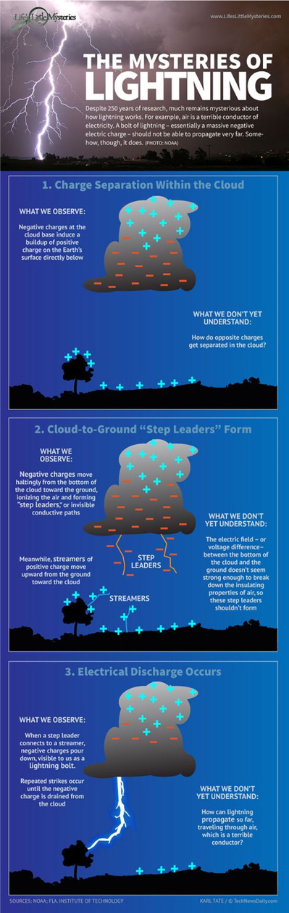
The temperature of the ionized gas in a lightning strike is typically 30,000 deg C, or five times hotter than the surface of the sun.
The current is typically 250,000A, but it only lasts for a few millionths of a second. Thus the average bolt of lightning could only provide the daily energy demand for perhaps 3 UK homes.
Worldwide though there are about 4 million flashes each day.

It was the American scientist/politician Benjamin Franklin who first established that lightning seemed to obey the same laws as electricity which was so intriguing to the scientists at the time.
He did this by attracting lighting from the sky by flying a kite during a thunderstorm. He was lucky not to have killed himself.
He also realised the significance of pointed conductors, and as a result invented the lighting conductor.
Because of the animosity which existed between America and Britain at this time, the British King (King George III) insisted that the lightning conductors at his palace should have round knobs on top.
The then president of the Royal Society resigned in protest at such idiocy.
These lightning conductors also attracted controversy when they were attached to the steeples of churches.
Many people believed that (i) they actually attracted lightning, and (ii) that the conductors were attempting to obstruct the will of God.
“Benjamin Franklin’s lightning conductor is a sacrilege that tries to avert the wrath of God. The destruction of Lisbon by the earthquake and tidal wave is God’s punishment of Man for the sacrilege”.
From a sermon by a Boston Minister (1753).
Or how about Jonas Hanway, who introduced the umbrella into England also in the 18th century and was criticized ''for defying the heavenly purpose of rain, which obviously was to make people wet.''

What do lightning conductors and Global Warming have in common?

Me: Give me some examples of what you can NOT insure your house against.
Students: Floods, hurricanes, earthquakes
Me: What are these collectively known as?
Students: Acts of God
Me: Why are they referred to as Acts of God?
Students: Because you can’t predict when or if they’re going to happen.
Me: But why would you call those events ‘Acts of God’?
Students: Because you can’t predict when or if they’re going to happen.
Repeat three times.
Finally:
Me: But why would you call those things ‘Acts of God’?
Student: Because God must have wanted those things to happen – or at least that’s what the people believed back then.
Me: Exactly. And before you all laugh at how ridiculous that sounds remember that it’s not that they were any less intelligent than we are now, it’s just that life in the 16th and 17th century was incomparably different to today. We live in a so-called age of reason. We know you can’t say ‘well that’s obviously what God wanted’ every time something bad happens. And I’m pretty sure that if our civilisation survives another century or two the people who are around then will look back at some of the rather bizarre belief systems that we subscribe to.
Even Newton himself fell into this way of thinking. When he found out that the orbits of the planets didn’t quite match his mathematical equations his response was to say that God obviously needs to step in and give them a nudge every so often. It took Einstein to explain that the problem was that Newton’s equations weren’t exact enough and it needed his (Einstein’s) Theory of Relativity to sort out the anomaly.

The point is that, as with so much of the Church’s teachings, its beliefs can be traced back to either St. Augustine or St. Thomas Aquinas. In this case both believed that the air was filled with seriously questionable characters. Aquinas wrote that “Rain and winds, and whatsoever occurs by local impulse alone, can be caused by demons. It is a dogma of faith that the demons can produce winds, storms, and rain of fire from heaven.”
And so, presumably, can God.

So when Franklin suggested that his lightning rod could save church buildings he naturally thought that this would be well received (in fact he considered it to be one of his greatest accomplishments, which is no mean feat when one considers that he was also one of the founding fathers of the United States.) It turns out that his suggestion went down like the proverbial lead balloon.

If a building struck by lightning was an Act of God, then interfering with this process was akin to thwarting God’s plan. And that, in the eyes of the Church authorities at least, couldn’t be a good thing. So they simply refused to put them in.

But there was one small problem. The church building was invariably the tallest structure in every village and town. So it was also the most likely to get hit. Now as you can imagine this confused people greatly. Not only that but the bell-ringers whose job it was to alert the townsfolk about the impending storm also tended to become the first victims of any lightning strike. In Germany alone approximately 300 bell-ringers lost their lives in the last 30 years of the 19th century.

So slowly but surely Church authorities began to relent and accept that maybe it was time to accept that there was something to be said for these so-called ‘blasphemous devices’ after all. Lucky for them it wasn’t too late.

So what’s all this got to do with Global Warming?
According to one 2006 study, 76 percent of Republican citizens profess a belief in the Second Coming (the so-called ‘Apocalypse’). They also represent one of the largest groups who oppose scientific teaching on Global Warming. They simply refuse to accept that Global Warming has the potential to change the world irrevocably. Why? Because the end of the world will come at a time of God’s choosing, not ours, so whatever mankind is doing right now, it’s certainly not going to bring about the destruction of civilisation.

These religious conservatives have become a very powerful force in American politics in recent decades (how that came to be is an equally fascinating story, but not for today).

Add to this the lobby group for oil and other fossil fuels and you have a voice that is both loud and very difficult to dislodge.

Now for fun throw in optimism bias which is evolutionary hardwired into all of us. Optimism Bias is the belief that the future will be better than the past. So for example 10% of Americans expect to live to be 100 when in fact only 0.02% are likely to live that long. We all experience optimism bias. It’s why none of us mention Global Warming when political canvassers call to our door. We all just assume that it will get sorted somehow. It may even explain why we are all so reluctant to engage with the concept of our own mortality; deep down we all think we’re going to live forever.

So you can see why Global Warming remains low on everybody’s radar?

And it will most likely remain that way – until it’s too late.

Unlike lightning conductors.

Ions can also affect how we feel.
Positive ions tend to induce a feeling of lethargy and irritability in the 30 per cent of the population who find themselves susceptible, and may induce nausea and headaches.
Air laden with positive ions occur during a thunderstorm and also in the vicinity of fire.
Negative ions, on the other hand, have quite the opposite effect and induce a sense of physical and mental well-being. There is normally a high concentration of negative ions near the seashore, and in the rarefied air at the summits of very high mountains.
Negative ions are also created in the domestic shower and this is said to be why a shower produces a feeling of freshness and invigoration superior to the traditional bath.
Taken from an article by the late great Brendan McWilliams in The Irish Times.

Did you know?
On a normal day, a cubic centimetre of air contains 1,200 positive ions and 1,000 negative ions.
These negative ions are generally oxygen with an extra electron, and the positive ones are carbon dioxide minus an electron.

SLOP
(permittivity of free space = 8.9 × 10⁻¹² F m⁻¹; charge on the electron = 1.6 × 10⁻¹⁹ C)

[2010 OL]  How would you detect the presence of an electric field? | Using an electroscope // electric field sensor // electric field meter
[2009 OL]  Name the instrument shown in the diagram. | A gold leaf electroscope
[2005 OL]  The diagram shows a gold leaf electroscope.  Name the parts labelled A and B. | A = insulation, B = metal case (sometimes the case is wooden but if so then there must be a metal strip inside it).
[2005 OL]  Explain why the gold leaf on the electroscope diverges when a positively charged rod is brought close to the metal cap.  The positively charged rod is held close to the electroscope and the metal cap is then earthed.  Explain why the gold leaf collapses. | Some of the electrons at the bottom of the electroscope are attracted to the top due to the positive charge on the rod and as a result there is an excess of positive charge on the bottom, including on the gold leaf. Because similar charges repel the gold leaf moves away from the main section.  Some of the positive charges are repelled by the rod and so flow to the ground.
- [2007 OL]
- The diagram shows a positively charged gold leaf electroscope.
Describe how an electroscope is given a positive charge.
- What is observed when the cap of an electroscope is earthed?
- Why does this happen?
How is the cap of the electroscope earthed?
Describe how an electroscope can be charged by induction  Describe, with the aid of a labelled diagram, how you would charge a conductor by induction. | Apparatus e.g. conductor hanging from insulated thread  Bring a charged rod close to the conductor.  Earth the conductor by touching it with your finger.  Remove your finger, then remove the rod.
Give one use of an electroscope. | To detect charge
What is the unit of electric charge? | The coulomb
State Coulomb’s law of force between electric charges. | The force between two charges is proportional to the product of the charges and inversely proportional to the square of the distance between them.
Why is Coulomb’s law an example of an inverse square law? | Force is inversely proportional to distance squared.
Give two differences between the gravitational force and the electrostatic force between two electrons. | Gravitational force is much smaller than the electrostatic force.  Gravitational force is attractive, electrostatic force (between two electrons) is repulsive.
Calculate the force between the following two charges:
Charge 1: 1 C
Charge 2: 1 C
Distance: 1 m
Calculate the force between the following two charges:
Charge 1: 6.0 × 10⁻⁶ C
Charge 2: 7 × 10⁻⁹ C
Distance: 3 × 10⁻⁸ m
Define electric field strength. | Electric field strength is defined as force per unit charge at that point.
Give the unit of electric field strength | The unit of electric field strength is the newton per coulomb (N C⁻¹).
The diagram shows a negative charge – Q at a point X.  Copy the diagram and show on it the direction of the electric field strength at Y. | Arrow towards X.
What is the force exerted on an electron when it is in an electric field of strength 5 N C^{–1}? | F = Eq ⇒ F = (5)(1.6 × 10^{–19})  ⇒ F = 8.0 × 10^{–19} N
A pear-shaped conductor is placed on an insulated stand as shown. Copy the diagram and show how the charge is distributed over the conductor when it is positively charged.
Give an application of the fact that all charge resides on the outside of a conductor.
Under what circumstances will point discharge occur? | When the density of charge is sufficiently high.
How does the lightning conductor prevent damage to the building? | Provides (safe) path for flow of current if struck
Suggest a suitable material for a lightning conductor. | Metal e.g. copper.
Give one effect of static electricity? | Electrostatic shielding / co-axial cable / TV (signal) cable / to protect persons or equipment, enclose them in hollow conductors /Faraday cages (there is no electric field inside a closed conductor), etc.
Identify two hazards caused by static electricity. | Lightning, static discharge, receive shock after walking across carpets, attracts objects, can damage electronics.
The build-up of electric charge can lead to explosions. Give two examples where this could happen. | Explosion in flour mills /explosion when fuelling aircraft/ damage to electronic devices / electrical storm / static cling, etc.
How can the build-up of electric charge on an object be reduced? | By earthing the object (i.e. using a conductor to connect the object to the earth which allows the charge to flow to earth).

Static electricity Exam Questions 2022 - 2002

Gold leaf electroscope: Ordinary Level

2013 Question 12 (c) [Ordinary Level]
- State Coulomb’s law of force between electric charges.
- The diagram shows a positively-charged electroscope.
Give a use for an electroscope.
- How can an electroscope be given a positive charge?
- What is observed if you touch the cap of the electroscope with your finger?
- Explain why this happens.

2010 Question 9 (a) [Ordinary Level]
- State Coulomb’s law of force between electric charges.
- How would you detect the presence of an electric field?
- What is the unit of electric charge?
- How does the lightning conductor prevent damage to the building?
- Suggest a suitable material for a lightning conductor.

2007 Question 9 (a) [Ordinary Level]
- State Coulomb’s law of force between charges.
- The diagram shows a positively charged gold leaf electroscope.
Describe how an electroscope is given a positive charge.
- What is observed when the cap of an electroscope is earthed?
- Why does this happen?
- How is the cap of the electroscope earthed?

2005 Question 12 (c) [Ordinary Level]
The diagram shows a gold leaf electroscope.
- Name the parts labelled A and B.
- Give one use of an electroscope.
- Explain why the gold leaf diverges when a positively charged rod is brought close to the metal cap.
- The positively charged rod is held close to the electroscope and the metal cap is then earthed.
Explain why the gold leaf collapses.

2003 Question 12 (c) [Ordinary Level]
- What is the unit of electric charge?
- Describe, with the aid of a labelled diagram, how you would charge a conductor by induction.
- The build-up of electric charge can lead to explosions. Give two examples where this could happen.
- How can the build-up of electric charge on an object be reduced?

2018 Question 9 (a) [Ordinary Level]
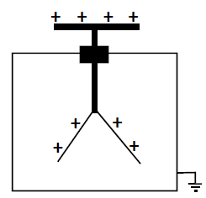
The diagram shows a positively charged gold leaf electroscope.
  - State Coulomb’s law of force between charges.
  - State one use of an electroscope.
  - How can an electroscope be given a positive charge?
  - What is observed when the cap of a charged electroscope is earthed?
  - Explain this observation.
  - How could the cap of the electroscope be earthed?

2020 Question 8 [Ordinary Level]
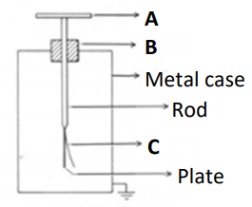
A gold leaf electroscope is used to perform experiments involving static electricity.
- Name the parts of the gold leaf electroscope labelled A, B and C.
- When two different materials are rubbed together, they become electrically charged. Describe how a student would charge a plastic rod.
- How would the student use a gold leaf electroscope to show that the rod is charged?
- State the SI unit of electric charge.
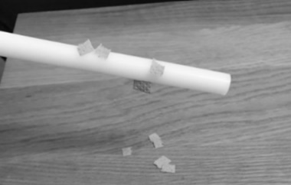
- The photograph above shows a charged plastic rod attracting small pieces of paper to it. Explain how this happens.
- Describe, with the aid of a labelled diagram, an experiment to show an electric field pattern. On your diagram, show the electric field, including its direction.
- Coulomb’s law describes the force between static charges.
It is an example of an inverse square law.
State another example of an inverse square law.

2021 Question 14 (b) [Ordinary Level]
Lightning is a naturally occurring electrostatic discharge. It is caused by an imbalance between two electrically charged regions, usually a cloud and the ground.
- As charge builds up on a cloud, the cloud induces a charge on objects on Earth.
Explain how objects can be charged by induction. (A labelled diagram may help your answer.)
- Static electricity builds up in the cloud and releases 0.9 GJ of energy in a time of 0.3 ms as it discharges.
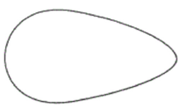
Calculate the power generated when lightning discharges.

- Draw a diagram to show the distribution of charge on a pear shaped conductor.
- Describe an experiment to show that static charge accumulates on the outside of a metal object.

Gold leaf electroscope: Higher level

2011 Question 9 (b) [Higher Level]
- Draw a labelled diagram of an electroscope.
- Why should the frame of an electroscope be earthed?
- Describe how to charge an electroscope by induction.

Electric fields / Electric field strength Ordinary level

2023 Question 14 (c) [Ordinary level]
The diagram shows the electric field around two oppositely charged particles.
- Draw the electric field lines around two positively charged particles held close to each other.

- The force between two electric charges is calculated using Coulomb’s law.
Coulomb’s law is an example of an inverse square law.
Describe what is meant by an inverse square law.

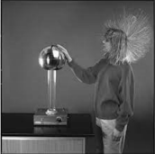
- Electric charge builds up on the dome of a Van de Graaff generator.
Describe a laboratory experiment that uses a Van de Graaff generator to show that charge resides on the outside of a hollow metal conductor.

- The picture on the right shows a student touching a Van de Graaff generator.
Explain why her hair is standing up.

Electric fields / Electric field strength Higher level

2022 Question 9 (a) [Higher level]
A metal sphere of diameter 5 cm holds a charge of –6 μC.
- Draw the electric field around the sphere.
- Calculate the electric field strength at a distance of 3 cm from the surface of the sphere.

2008 Question 5 [Ordinary level]
What is the force exerted on an electron when it is in an electric field of strength 5 N C^{–1}?

2013 Question 12 (c) [Higher Level]
- Define the unit of charge, the coulomb.
- State Coulomb’s law.
- Calculate the force of repulsion between two small spheres when they are held 8 cm apart in a vacuum (each sphere has a positive charge of +3 μC).
- Copy the diagram above and show on it the electric field generated by the charges.
- Mark on your diagram a place where the electric field strength is zero.

2003 Question 12 (c) [Higher Level]
- State Coulomb’s law of force between electric charges.
- Define electric field strength and give its unit.
- How would you demonstrate an electric field pattern?
- The diagram shows a negative charge – Q at a point X.
Copy the diagram and show on it the direction of the electric field strength at Y.

2005 Question 10 [Higher Level]
- Define electric field strength.
- State Coulomb’s law of force between electric charges.
- Why is Coulomb’s law an example of an inverse square law?
- Give two differences between the gravitational force and the electrostatic force between two electrons.
- Describe an experiment to show an electric field pattern.
- Calculate the electric field strength at the point B, which is 10 mm from an electron.
- What is the direction of the electric field strength at B?
- A charge of 5 μC is placed at B. Calculate the electrostatic force exerted on this charge.
(permittivity of free space = 8.9 × 10^{–12} F m^{–1}; charge on the electron = 1.6 × 10^{–19} C)

Question 10 Higher Level 2023
The Van de Graaff generator is named after the American physicist Robert J. Van de Graaff.
It is an electrostatic generator that accumulates charge on a hollow metal dome and produces high voltages which can be used in the production of X‐rays.
In a Van de Graaff generator, point discharge is used to move charge on to a belt at the lower comb in the generator.
- Describe how point discharge occurs.
- Describe a laboratory experiment to demonstrate point discharge.

The dome of a Van de Graaff generator has a diameter of 32 cm.
A large electric field exists around the dome when it is given a charge of +200 nC.
- Draw the electric field around the dome.
- Calculate the electric field strength at the surface of the dome.
- Calculate the force experienced by an electron placed at the surface of the dome.

2010 Question 12 (d) [Higher Level]
- Define electric field strength and give its unit of measurement.
- Copy the diagram into your answerbook and show on it the direction of the electric field at point P.

- Calculate the electric field strength at P.
- Under what circumstances will point discharge occur?
(permittivity of free space = 8.9 × 10^{–12} F m^{–1})

Electric field strength a distance ‘d’ from the surface of a charged sphere

2007 Question 8 [Higher Level]
- Define electric field strength and give its unit of measurement.
- Describe how an electric field pattern may be demonstrated in the laboratory.
- The dome of a Van de Graff generator is charged.
The dome has a diameter of 30 cm and its charge is 4 C.
A 5 μC point charge is placed 7 cm from the surface of the dome.
Calculate the electric field strength at a point 7 cm from the dome
- Calculate the electrostatic force exerted on the 5 μC point charge.
- All the charge resides on the surface of a Van de Graff generator’s dome. Explain why.
- Describe an experiment to demonstrate that total charge resides on the outside of a conductor.
- Give an application of this effect.
(permittivity of free space = 8.9 × 10^{–12} F m^{–1})

2015 Question 8 [Higher Level]
- Define electric field strength.
- Both Van de Graaff generators and gold leaf electroscopes are used to investigate static electricity in the laboratory.
Draw a labelled diagram of a gold leaf electroscope.
- Describe how it can be given a negative charge by induction.
- A Van de Graaff generator can be used to demonstrate point discharge.
Explain, with the aid of a labelled diagram, how point discharge occurs.
- Describe an experiment to demonstrate point discharge.

- The polished spherical dome of a Van de Graaff generator has a diameter of 40 cm and a charge of +3.8 μC.
What is the electric field strength at a point 4 cm from the surface of the dome?

2019 Question 7 [Higher Level]

In a thunderstorm different parts of a cloud become positively and negatively charged. There is a large electric field and a large potential difference between different parts of the cloud and between the cloud and the ground.
- What is meant by potential difference?
- State its unit.
- Define electric field strength.
- Describe how an insulated spherical conductor can be charged positively by induction.
- A spherical conductor has a diameter of 12 cm. It is charged positively by induction.
Draw the electric field around the charged conductor.
- There is an electric field strength of 2.3 N C^{‐1} at a distance of 5 cm from the surface of this spherical conductor. Calculate the charge on the conductor.
- Explain how point discharge occurs.
- Describe how point discharge can be demonstrated in the laboratory.

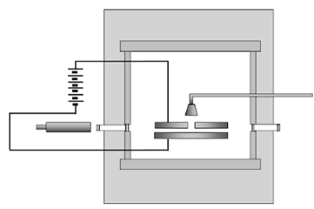
The Millikan oil drop experiment

2021 Question 13 [Ordinary Level]
Read the following passage and answer the questions below.
The Millikan Oil Drop Experiment
An experiment performed by Robert Millikan in 1909 determined the size of the charge on an electron. He also determined that there was a smallest unit charge. He received the Nobel Prize for his work.

The experiment Millikan performed involved putting a charge on a tiny drop of oil using X‐rays and measuring how strong an applied electric field had to be in order to stop the oil drop from falling.
By attaching a battery to the plates above and below the chamber, Millikan was able to apply an electric voltage. The electric field produced in the chamber by this voltage would act on the charged oil drop.
If the voltage was just right, the electromagnetic force would just balance the force of gravity on a drop, and the drop would hang suspended in mid‐air.
Using a microscope, he measured the radius of the drop. Given that the density of the oil was known, Millikan could calculate the mass of each oil drop. Using this mass, he could calculate the weight of one drop. He could then determine the electric charge on the drop.
By varying the charge on different drops, he noticed that the charge was always a multiple of 1.6 × 10⁻¹⁹ C, the charge on a single electron.
Adapted from ffden‐2.phys.uaf.edu/212_fall2003.web.dir/ryan_mcallister

  - What did Millikan determine with his 1909 oil drop experiment?
  - What is the size of the charge on one electron?
  - A drop has a volume of 2.03 × 10⁻¹⁷ m³ and a density of 886 kg m⁻³. Calculate the mass of the drop.
  - Draw the circuit symbol for a battery.
  - In the oil drop experiment, Millikan applied an electric field between the plates until the drop no longer moved up or down. What is an electric field?
  - Sketch the electric field that is formed between two oppositely charged parallel plates.
  - Show the forces acting on the drop when it is not moving up or down.

2016 Question 12 (b) [Higher Level]
In 1909 Robert Millikan determined the charge on an electron by experiment.
A tiny drop of oil was placed between two horizontal plates, one directly above the other as shown. The oil drop was ionised by X-rays so that it became negatively charged. An electric field was applied between the plates until the drop no longer moved up or down.

- Define electric field strength.
- In your answer book, sketch the electric field pattern between two oppositely charged parallel plates.
- Draw a diagram to show the forces acting on the drop of oil when it is stationary.
- The electric field strength between the plates was 3.6 × 10⁴ V m^{–1} when the drop of oil was stationary, and the mass of the drop was 2.4 × 10^{–15} kg.
Calculate the charge of the drop.
- How many excess electrons are on this drop?
(acceleration due to gravity = 9.8 m s^{–2})

General questions

2002 Question 11 [Higher Level]
Read the following passage and answer the accompanying questions.
Benjamin Franklin designed the lightning conductor. This is a thick copper strip running up the outside of a tall building. The upper end of the strip terminates in one or more sharp spikes above the highest point of the building. The lower end is connected to a metal plate buried in moist earth. The lightning conductor protects a building from being damaged by lightning in a number of ways.
During a thunderstorm, the value of the electric field strength in the air can be very high near a pointed lightning conductor. If the value is high enough, ions, which are drawn towards the conductor, will receive such large accelerations that, by collision with air molecules, they will produce vast additional numbers of ions. Therefore the air is made much more conducting and this facilitates a flow of current between the air and the ground. Thus, charged clouds become neutralised and lightning strikes are prevented. Alternatively, in the event of the cloud suddenly discharging, the lightning strike will be conducted through the copper strip, thus protecting the building from possible catastrophic consequences.
Raised umbrellas and golf clubs are not to be recommended during thunderstorms for obvious reasons.
On high voltage electrical equipment, pointed or roughly-cut surfaces should be avoided.
(Adapted from “Physics – a teacher’s handbook”, Dept. of Education and Science.)

  - Why is a lightning conductor made of copper?
  - What is meant by electric field strength?
  - Why do the ions near the lightning conductor accelerate?
  - How does the presence of ions in the air cause the air to be more conducting?
  - How do the charged clouds become neutralised?
  - What are the two ways in which a lightning conductor prevents a building from being damaged by lightning?
  - Why are raised umbrellas and golf clubs not recommended during thunderstorms?
  - Explain why pointed surfaces should be avoided when using high voltage electrical equipment.

2011 Question 9 (c) [Higher Level]
- How does a full-body metal-foil suit protect an operator when working on high voltage power lines?
- Describe an experiment to investigate the principle by which the operator is protected.

2011 Question 9 (a) [Higher Level]
Part (ii) this one is quite tricky and best left for sixth year
- State Coulomb’s law.
- Two identical spherical conductors on insulated stands are placed a certain distance apart.
One conductor is given a charge Q while the other conductor is given a charge 3Q and they experience a force of repulsion F.
The two conductors are then touched off each other and returned to their original positions.
What is the new force, in terms of F, between the spherical conductors?

2: POTENTIAL DIFFERENCE

Student notes

Potential difference
The potential difference (p.d.) between two points is the work done when a charge of 1 coulomb moves from one point to the other.
The unit of potential difference is the volt (symbol V)

The volt
The potential difference between two points is one volt if one joule of work is done when bringing a charge of one coulomb from one point to another.

An everyday word for the term ‘potential difference’ is ‘voltage’.

Relationship between work, charge and potential difference

work = potential difference × charge
W = V × Q

Potential at a point

The potential at a point refers to the work done in bringing a positive charge from that point to earth.

3: CAPACITANCE

Student notes

Capacitors
A capacitor is a device used to store separated charge.

The symbol for capacitance is C
Don’t confuse ‘capacitance’ (symbol C) with ‘charge’ (symbol Q).
The unit of capacitance is the farad; symbol is F.


Circuit symbol for a capacitor:

The capacitance of a conductor is the ratio of the charge on the conductor to its potential.

$$C= \frac{Q}{V}$$

Related maths questions
$$C= \frac{Q}{V}$$

2019 Question 12 (b) [Ordinary Level]  The charge on the capacitor is 0.025 C and the potential difference across it is 250 V.  Calculate the capacitance. | $C=\frac{Q}{V}=\frac{0.025}{250}$ = 10⁻⁴ F
2017 Question 12 (d) [Ordinary Level]  A capacitor has a capacitance of 6×10⁻² F.  Calculate the charge stored on the capacitor when it is connected to a 12 V d.c. power supply. | $C=\frac{Q}{V}$  Q = CV Q = (${6×10}^{-2})(12)$ = 0.72 C
2012 Question 12 (d) [Ordinary Level]  The capacitor has a capacitance of 200 μF. Calculate its charge when connected to a 6 V battery. | $C=\frac{Q}{V}$  Q = CV. Q = (200×10⁻⁶)(6) = 1.2 ×10⁻3 C
2010 Question 5 [Higher level]  What is the positive charge stored on a 5 μF capacitor when connected to 120 V d.c. supply? | $C=\frac{Q}{V}$ Q = CV  Q= (5 × 10^{–6})(120) = 6.0 × 10^{–4} C

The parallel plate capacitor

The relationship between capacitance, overlap area and distance between plates for a parallel plate capacitor is as follows
$$C=ε\frac{A}{d}$$

Related maths exam questions
2011 Question 5 [Higher level]  The capacitance of a parallel plate air capacitor is 5 pF.  If the plates of the capacitor are 2 cm apart, what is the common area of the plates?  Take ε_{air} = ε₀ = 8.854 × 10⁻¹² F m⁻¹ | $C=\frac{εA}{d}$ $A=\frac{Cd}{ε}$  $A=\frac{({5×10}^{-12})(2×{10}^{-2})}{{8.854×10}^{-12}}$  A = 0.0113 m²
2006 Question 12 (b) [Higher Level]  The plates of an air filled parallel plate capacitor have a common area of 40 cm² and are 1 cm apart.  Calculate the capacitance of the capacitor.  Take ε_{air} = ε₀ = 8.85 × 10⁻¹² F m⁻¹ | There are 10,000 (1×10⁴) cm² in one m².  Therefore 1 cm² =1×10⁻⁴ m²  40 cm² =40×10⁻⁴ m²  $C=\frac{εA}{d}$ $C=\frac{(8.85 ×{10}^{-12})(40×{10}^{-4})}{0.01}$ C = 3.54 × 10⁻¹² F
2014 Question 9 [Higher Level]  The capacitance of a parallel plate capacitor is 12 μF.  While the battery is connected the distance d is increased by a factor of three.  Calculate the new capacitance. | C ∝ $\frac{1}{d}$  So if the distance increases by a factor of 3 then the capacitance decreases by a factor of 3.  So new capacitance is 3 times smaller = 4 μF

Relative permittivity ε_{r}

What is relative permittivity and its unit?

Relative permittivity or a medium is defined as the ratio of the permittivity of that medium to the permittivity of a vacuum. As it is the ratio of permittivities it has no unit.
$$ε_{r}=\frac{ε}{ε_{0}}$$

2021 Question 12 [Higher Level]
The plates of a parallel plate capacitor of capacitance 3.2 pF have a common area of 20 cm² and are 15 mm
apart. Calculate the relative permittivity of the capacitor’s dielectric.
Solution

Area A = 20 cm² = 0.0020 m² d = 15 mm = 0.015 m
$C=ε\frac{A}{d}$ ${3.2×10}^{-12}=(ε)(\frac{0.0020 }{0.015})$ ε = 2.4 × 10⁻¹¹ F m⁻¹

We know that ε₀ = 8.854 ×10⁻⁹ F m⁻¹, so relative permittivity = $\frac{{8.854×10}^{-9}}{{2.4×10}^{-9}}$.

Ans: ε_{r} = 2.71

To demonstrate the factors affecting the capacitance of a parallel plate capacitor

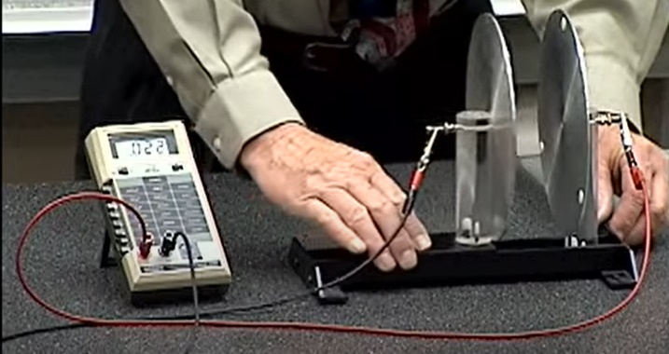

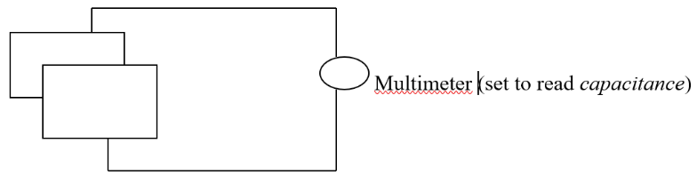

- Connect the two parallel plates to a multimeter set to read capacitance. Note the capacitance.
- Increase the distance between them – note that the capacitance decreases.
- Move one plate slightly to the side (decreasing the overlap area) – note that the capacitance decreases.
- Place different slabs of insulating material between the plates such as plastic and glass – note that the capacitance is lowest when nothing (air) is between the plates.

So the three factors that affect the capacitance of a parallel plate capacitor are
- Overlap area
- Distance between the plates
- Permittivity of the medium
Exam tip: “medium” is not an acceptable answer

To show that a charged capacitor stores energy

- Set up as shown.
- Close the switch to charge the capacitor.
- Remove the battery and connect the terminals together to ‘short’ the circuit.
- The bulb will flash as the capacitor discharges, showing that it stores energy.

The energy stored in a capacitor

$$W=\frac{1}{2}CV^{2}$$

2002 Question 5 [Higher Level]  How much energy is stored in a 100 μF capacitor when it is charged to a potential difference of 12 V? | E = ½ CV²  = ½ (100 × 10⁻⁶)(12)²  = 7.2 × 10⁻³ J
2007 Question 5 [Higher Level]  Calculate the energy stored in a 5 μF capacitor when a potential difference of 20 V is applied to it. | E = ½ CV²  = ½ (5 x 10⁻⁶)(20)²  = 1.0 x 10⁻³ J
2005 Question 5 [Higher Level]  A capacitor of capacitance 100 μF is charged to a potential difference of 20 V.  What is the energy stored in the capacitor? | E = ½CV²  E = ½(100 × 10⁻⁶)(20)²  = 0.02 J
2014 Question 9 [Higher Level]  Two parallel metal plates are placed a distance d apart in air.  The plates form a parallel plate capacitor with a capacitance of 12 μF. A 6 V battery is connected across the plates.  - Calculate the charge on each plate  - Calculate the energy stored in the capacitor. | - Calculate the charge on each plate  C = $\frac{Q}{V}$ Q = CV = (12×10⁻⁶)(6) = 72 ×10⁻⁶ C  - Calculate the energy stored in the capacitor.  E = ½CV² = ½ (12×10⁻⁶)(6)² = 216 ×10⁻⁶ J
2009 Question 9 [Higher Level]  A 64 μF capacitor in a defibrillator is charged to a potential difference of 2500 V.  The capacitor is discharged through electrodes attached to the chest of a heart attack victim.  - Calculate the charge stored on each plate of the capacitor.  - Calculate the energy stored in the capacitor. | - Calculate the charge stored on each plate  $C=\frac{Q}{V}$ Q = CV ⇒ Q = (64 × 10⁻⁶)(2500) ⇒ Q = 0.16 C  - Calculate the energy stored in the capacitor.  E = ½ CV² = ½ (64 × 10⁻⁶)(2500)² = 200 J

Common applications of capacitors


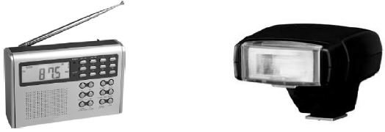

- The ‘flash’ on a camera (an internal capacitor stores charge and releases it very quickly).
- Tuning into a radio station (turning the dial changes the overlap area of an internal capacitor which in turn changes the frequency that gets amplified).
For a more detailed explanation see the link on the Capacitance page of thephysicsteacher.ie).
- Touchscreens (the user’s finger acts as a plate of a capacitor). See 2014 Question 9 [HL]
- Allows alternating current (a.c.) to pass through it but blocks direct current (d.c.).
- Smoothing out variations in direct current.
- Used in circuits to only allow alternating current of a specific frequency to flow.

2002 Question12 (c) [Ordinary Level]
Diagram A shows a capacitor connected to a bulb and a 12 V a.c. supply.

Diagram B shows the same capacitor connected to the bulb, but connected to a 12 V d.c. supply.

What happens in each case when the switch is closed?
Explain your answer.

Solution
Diagram A; Bulb remains lighting
Diagram B: Bulb flashes and then stays off

Explanation:
A capacitor allows alternating current to flow but does not allow direct current to flow.

Review of some electrical symbols and units

Quantity | Symbol | Unit | Symbol of unit
Charge | Q | coulombs | C
Current | I | amps | A
Capacitance | C | farads | F
Electric Field Strength | E | newton per coulomb | N/C


Capacitors are also used in defibrillators (see 2009 Question 9, HL) which is as good an excuse as any to include the following →
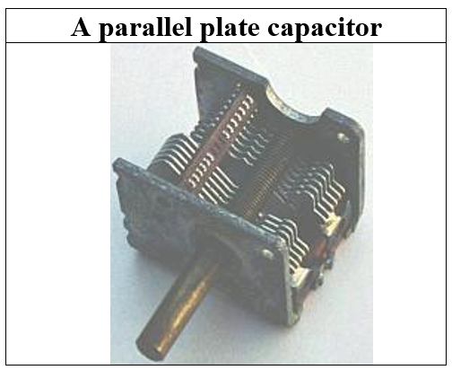

SLOP

Define potential difference. | The potential difference between two points is the work done in bringing a charge of 1 Coulomb from one point to the other.
Name an instrument used to measure potential difference. | A voltmeter
Define capacitance. | The capacitance of a conductor is the ratio of the charge on the conductor to its potential.
List the factors that affect the capacitance of a parallel plate capacitor. | Common area of plates, distance apart, permittivity of dielectric between plates.
How would you demonstrate that the capacitance of a parallel plate capacitor depends on the distance between its plates? | Connect the two parallel plates to a digital multi-meter (DMM) set to read capacitance.  Note the capacitance.  Increase the distance between them – note that the capacitance decreases.
Describe an experiment to demonstrate that a capacitor can store energy. | See notes
Give one use of a capacitor.

Describe an experiment to demonstrate that a capacitor can store energy.

Capacitance Exam Questions 2022 – 2002

Capacitance Ordinary Level

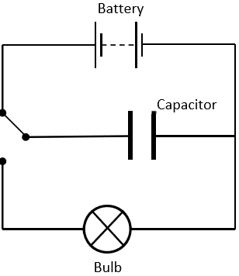
2019 Question 12 (b) [Ordinary Level]
A capacitor is used in the flash of a camera.
- Define capacitance.
- State the unit of capacitance.
- The light energy emitted by a flash is supplied by a capacitor. The charge on the capacitor is 0.025 C and the potential difference across it is 250 V.
Calculate the capacitance.
- In the flash circuit of a camera, energy is stored up and then suddenly released.
A capacitor stores energy when it is charged.
The circuit shown can be used to demonstrate that a capacitor stores energy.
Explain how the circuit is used.
- State another use for a capacitor.

2017 Question 12 (d) [Ordinary Level]
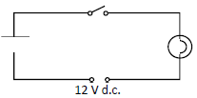
- State Coulomb’s law of force between electric charges.

A capacitor can be used to store electric charge.
A discharged capacitor with a capacitance of 6 × 10⁻² F is connected in a circuit with a bulb, a switch and a 12 V d.c. power supply as shown.

- What is observed when the switch is closed?
- What would be observed if a 12 V a.c. power supply had been used instead?
- Calculate the charge stored on the capacitor when it is connected to the 12 V d.c. power supply.
- State one application of a capacitor.

2012 Question 12 (d) [Ordinary Level]
A capacitor is connected to a switch, a battery and a bulb as shown in the diagram.
When the switch is changed from position A to position B, the bulb lights briefly.
- What happens to the capacitor when the switch is in position A?
- Why does the bulb light when the switch is in position B?
- Why does the bulb light only briefly?
- The capacitor has a capacitance of 200 μF. Calculate its charge when connected to a 6 V battery.
- Give a use for a capacitor.

2007 Question 9 (b) [Ordinary Level]
A capacitor is connected to a switch, a battery and a bulb as shown in the diagram. When the switch is moved from position A to position B, the bulb lights briefly.
- What happens to the capacitor when the switch is in position A?
- Why does the bulb light when the switch is in position B?
- When the switch is in position A the capacitor has a charge of 0.6 C, calculate its capacitance.
- Give a use for a capacitor.

2002 Question12 (c) [Ordinary Level]
- Define capacitance.
- Diagram A shows a capacitor connected to a bulb and a 12 V a.c. supply.
Diagram B shows the same capacitor connected to the bulb, but connected to a 12 V d.c. supply.
What happens in each case when the switch is closed? Explain your answer.
- Describe an experiment to demonstrate that a capacitor can store energy.

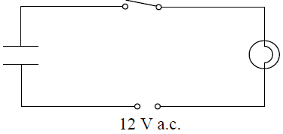
2015 Question 8 [Ordinary Level]
- Define capacitance. Name the unit of capacitance.
- The diagram shows a circuit with a bulb, switch, capacitor and a 12 V a.c. power supply.
What is observed when the switch is closed?
- What would be observed if a 12 V d.c. supply were used instead of the a.c. supply?
- What do these observations tell us about capacitors?
- The capacitor has a charge of 0.8 C when connected to the 12 V d.c. supply.
Calculate its capacitance.
- Describe an experiment to show that energy is stored in a charged capacitor.
- The photographs show a radio and a camera flash. Each of these devices makes use of a property of capacitors. Name the property used in each case.

Capacitance Higher level
(permittivity of free space = 8.85 × 10^{–12} F m^{–1})
2008 Question 12 (d) [Higher Level]
- Define capacitance.
- Describe how an electroscope can be charged by induction.
- How would you demonstrate that the capacitance of a parallel plate capacitor depends on the distance between its plates?

2006 Question 12 (b) [Higher Level]
- List the factors that affect the capacitance of a parallel plate capacitor.
- The plates of an air filled parallel plate capacitor have a common area of 40 cm² and are 1 cm apart.
The capacitor is connected to a 12 V d.c. supply. Calculate the capacitance of the capacitor.
- Calculate the magnitude of the charge on each plate.
- What is the net charge on the capacitor?
- Give a use for a capacitor.

2014 Question 9 [Higher Level]
Most modern electronic devices contain a touchscreen.
One type of touchscreen is a capacitive touchscreen, in which the user’s finger acts as a plate of a capacitor.
Placing your finger on the screen will alter the capacitance and the electric field at that point.
- Explain the underlined terms.
- Describe an experiment to demonstrate an electric field pattern.
- Two parallel metal plates are placed a distance d apart in air.
The plates form a parallel plate capacitor with a capacitance of 12 μF. A 6 V battery is connected across the plates.
Calculate the charge on each plate
- Calculate the energy stored in the capacitor.
- While the battery is connected the distance d is increased by a factor of three.
Calculate the new capacitance.
- A capacitor and a battery are both sources of electrical energy.
State two differences between a capacitor and a battery.
- Touchscreens also contain two polarising filters. What is meant by polarisation of light?
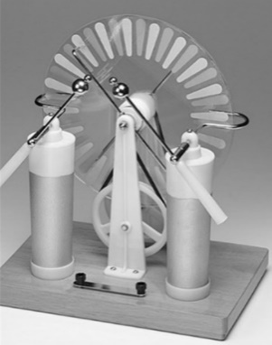
- Give one application of capacitors, other than in touchscreens.

2021 Question 12 [Higher Level]
The Wimshurst machine is an electrostatic generator for generating high voltages. It uses the principles of charging by induction and point discharge to store energy in two large capacitors.
Wimshurst machines provided be a source of high voltage for early X‐ray tubes.

- Describe a laboratory experiment to demonstrate charging by induction.
- Explain how point discharge occurs.
- The plates of a parallel plate capacitor of capacitance 3.2 pF have a common area of 20 cm² and are 15 mm apart. Calculate the relative permittivity of the capacitor’s dielectric.

- What would be the effect on the capacitance if the distance between the plates was doubled?
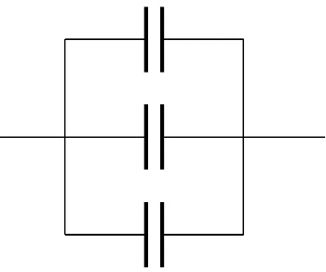
- Three such capacitors are connected in parallel as shown below.
Explain why the effective capacitance of this combination is 9.6 pF.
- Draw the electric field pattern in a charged parallel plate capacitor.

2009 Question 9 [Higher Level]
- Define potential difference.
- Define capacitance.
- A capacitor stores energy.
Describe an experiment to demonstrate that a capacitor stores energy.

- The ability of a capacitor to store energy is the basis of a defibrillator. During a heart attack the chambers of the heart fail to pump blood because their muscle fibres contract and relax randomly. To save the victim, the heart muscle must be shocked to re-establish its normal rhythm. A defibrillator is used to shock the heart muscle.
A 64 μF capacitor in a defibrillator is charged to a potential difference of 2500 V.
The capacitor is discharged through electrodes attached to the chest of a heart attack victim.
Calculate the charge stored on each plate of the capacitor.

- Calculate the energy stored in the capacitor.
- Calculate the average current that flows through the victim when the capacitor discharges in a time of 10 ms.
- Calculate the average power generated as the capacitor discharges.

2018 Question 12(c) [Higher Level]
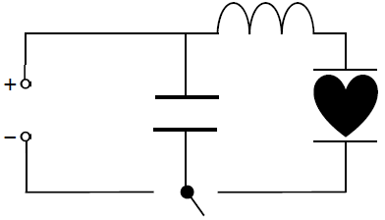
- Define capacitance and state its unit.

A capacitor is an important component of a defibrillator.
A simple defibrillator circuit is shown.
Each plate of a parallel plate capacitor in a defibrillator stores a charge of 0.11 C when a potential difference of 4.0 kV is applied across it.
- Calculate the energy stored in the capacitor.
- What is the net charge of the capacitor when it stores this energy?
- The capacitor discharges in a time of 15 ms.
Calculate the average current flowing as the capacitor discharges.
- Draw a diagram of the electric field between the charged plates of a parallel plate capacitor.

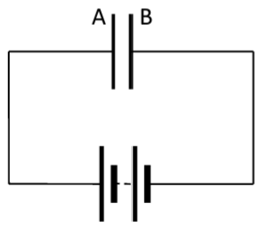
2022 Deferred examination Question 14 (c)
- What is a capacitor?
- Define the unit of capacitance, i.e. the farad.

A parallel plate capacitor of capacitance 3 µF has plates A and B connected across a 6 V battery, as shown in the diagram on the right.
- Calculate the charge on plate A
- Calculate the charge on plate B.
- Calculate the energy stored in the capacitor.
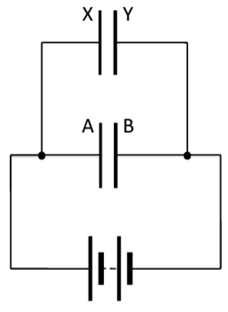
A 2 µF capacitor, with plates X and Y, is now connected in parallel with the first capacitor across the 6 V battery, as shown in the diagram on the left.
- Calculate the charge that is now on plate A.
- Calculate the charge that is now on plate B.
- Calculate the charge that is now on plate X.
- Calculate the charge that is now on plate Y.

- Calculate the capacitance of a single capacitor which could store as much energy as is stored in the two capacitors connected in parallel across the 6 V battery.

More challenging questions

2022 Question 9 (b) [Higher level]
A device that is designed to store energy when it holds a specific charge is called a capacitor.
- Describe an experiment to demonstrate that a charged capacitor stores energy.
- A parallel-plate capacitor has a dielectric of permittivity ε and its plates have an area of overlap A.
Voltage V is applied across the plates such that the capacitor stores energy W.
In terms of some or all of the symbols given, write an expression for
  - the charge on each plate of the capacitor,
  - the distance between the plates.

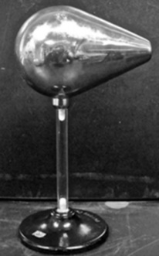
2020 Question 7 [Higher level]
All insulated metal bodies can store charge.
- Describe how a pear‐shaped metal body can be charged by induction.
- Draw a diagram to show the distribution of charge on the body after charging.

A charged capacitor stores energy.
- Define capacitance.
- Draw the circuit symbol for a capacitor.
- A 4000 µF capacitor is connected across 500 V.
The stored energy is converted to heat when the capacitor is discharged through a heating element placed in 40 g of water in an insulated container.
Calculate the maximum rise in temperature of the water.
- Describe an experiment to demonstrate how the capacitance of a parallel‐plate capacitor changes with the distance between the plates.

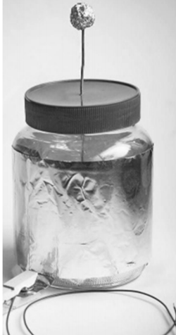
A Leyden jar acts as a parallel‐plate capacitor.
A student makes a Leyden jar in the laboratory. It consists of a cylindrical glass container of internal radius 6 cm. The glass in the jar is the capacitor’s dielectric and has a relative permittivity of 2.1 and a thickness of 5 mm.
Aluminium foil of height 17 cm coats the inside and outside vertical walls of the jar.
- Calculate the surface area of the inner cylinder of aluminium foil.
- Calculate the capacitance of the Leyden jar.
- What property of glass allows it to be used as a dielectric?
(specific heat capacity of water = 4180 J kg^{–1} K^{–1})

2004 Question 8 [Higher Level]
{you should have the Resistance chapter covered before trying the maths part of this question}
- Define potential difference.
- Define capacitance.
- Describe an experiment to demonstrate that a capacitor can store energy.

- The circuit diagram shows a 50 μF capacitor connected in series with a 47 kΩ resistor, a 6 V battery and a switch.
When the switch is closed the capacitor starts to charge and the current flowing at a particular instant in the circuit is 80 μA.
Calculate the potential difference across the resistor and hence the potential difference across the capacitor when the current is 80 μA.
- Calculate the charge on the capacitor at this instant.
- Calculate the energy stored in the capacitor when it is fully charged.
- Describe what happens in the circuit when the 6 V d.c. supply is replaced with a 6 V a.c. supply.

SOLUTIONS TO ORD. LEVEL EXAM QUESTIONS (MATHS PARTS ONLY) 2022 - 2002

2019 Question 12 (b) [Ordinary Level]
Calculate the capacitance.
$C=\frac{Q}{V}=\frac{0.025}{250}$ = 10⁻⁴ F

2017 Question 12 (d) [Ordinary Level]
A discharged capacitor with a capacitance of 6 × 10⁻² F is connected in a circuit with a bulb, a switch and a 12 V d.c. power supply as shown.
Calculate the charge stored on the capacitor when it is connected to the 12 V d.c. power supply.
$C=\frac{Q}{V}$ Q = CV Q = (${6×10}^{-2})(12)$ = 0.72 C

2012 Question 12 (d) [Ordinary Level]
The capacitor has a capacitance of 200 μF. Calculate its charge when connected to a 6 V battery.
$C=\frac{Q}{V}$ Q = CV. Q = (200×10⁻⁶)(6) = 1.2 ×10⁻3 C

2007 Question 9 (b) [Ordinary Level]
When the switch is in position A the capacitor has a charge of 0.6 C, calculate its capacitance.
$C=\frac{Q}{V}=\frac{0.6}{6}$ = 0.1 Farads

2015 Question 8 [Ordinary Level]
The capacitor has a charge of 0.8 C when connected to the 12 V d.c. supply.
Calculate its capacitance.
$C=\frac{Q}{V}=\frac{0.8}{12}$ = 0.07 F


If an object has more electrons than protons . . . Why two types of charge? Well the only way to explain that fact that two charged rods will either attract or repel each other is if there is some property of each rod which can exist in one of two states, and if this state is the same for both then they repel but if the states are different then they attract each other. But what do we call these states? It was the American scientist and politician Benjamin Franklin who put all this together and he chose the word ‘charge’ for the name of the property and he then went for positive and negative for the types of charge. We now know that it is only the negative charges (electrons) which move along a material. The positive charges (protons) are stuck in the nuclei of the atoms and most definitely do not move. As it so happens, all the phenomena we study in this chapter can be explained in terms of both types of charge moving, or just in terms of only electrons moving. For some reason we explain static electricity phenomena in terms of both charges moving but as an exercise you could try to explain each concept in terms of only electrons moving. Franklin famously investigated the nature of electricity by flying kites in lightning storms. He was able to demonstrate that lightning (in the heavens) was just another manifestation of the electric effects that scientists were studying here on Earth. This seems obvious now but at the time it was an incredible discovery.
Static electricity demonstrations are notoriously unreliable. Charged objects can discharge into the air if it is in anyway humid and even holding the rods above while trying to tie a knot around them can earth them rending them neutral. Rather than hanging them from strings I tend to balance them on a clock glass and try to only hold the rods from the very end with just my fingertips. Which is as good an opportunity as any to bring up one of the most important concepts in all of science. Question: How do you tell the difference between Physics, Chemistry and Biology? Answer: If it wiggles it’s Biology, if it smells it’s Chemistry and if it doesn’t work it’s Physics. True Dat.
Remember that if an object is neutral or uncharged, it does not mean that the object has no charge; merely that it has an equal amount of positive and negative charge, and they cancel each other out. The bricks in the wall are insulators and while the charges can’t move along the material they can rotate, and this is sufficient to create a charged surface on the outside of the wall.
This value is in the Formula & Tables book so you don’t need to learn it. By the way, a proton happens to have the same charge as an electron (we have no idea why.
We chose a gold leaf electroscope for the simple reason that you can see that it is charged at the end. You can however apply the same process to any insulated conductor, say a table-tennis ball covered with tin foil hanging by a string. The only issue is that it looks exactly the same before as after so not quite as impressive.
Exam tip: The charged rod is brought near to but does not touch the electroscope; to state or imply that it does meant only getting 4 marks out of 10 when it was asked in 2008}
Coulomb’s Law The direction of the force is an attractive force if they are opposite charges, and a repulsive force if they are similar charges. ‘Permittivity’ is actually an unfortunate term – it should be called ‘unpermittivity’ or something more helpful, because the higher the value of ε, the less will be the force between the two charges. Unless I completely misunderstand what’s going on here which I wouldn’t rule out either. Note that ε_{air} (the permittivity of air) is taken to have the same value as ε₀ (the permittivity of a vacuum or free space).
You can ignore whether the charge is positive or negative while doing the mathematical calculations. It only becomes relevant when considering the direction of the related electric field, which is something we pick up on in the next section.
An electric field line is a line drawn in an electric field showing the direction of the force on a positive charge if placed in the field. Don’t leave out the part in italics. A simpler way of saying this is to say that the lines come out of positive charges and go into negative charges. Note that where the electric field is strong, the field lines are close together; where the field is weak the lines are far apart.
To demonstrate electric field patterns I’m not too sure what’s going on here. I’m guessing that the oil is made up of polar molecules which means that one side of the molecule is positive and the other side negative. The negative side then turns towards the positive electrode (metal plate), and will even try to move towards it if it can overcome the inertia of the fluid. The semolina is just there for the ride, but acts to illustrate the motion of the oil underneath. Alternatively it may be that the semolina moves and the oil remains still. Or it could be a little of both.
Why have a concept called ‘electric field strength’? Because we may need to know what effect a given charge would have on another charge, if that second charge was placed a certain distance from it. But you can’t say that the first charge would produce a force of say 10 newtons. Why not? Because the size of the force depends on the magnitude of the two charges. So to get around this we need a nominal second charge, and it makes sense to nominate this second charge to be unit charge, i.e. one coulomb. This means that if we know the effect the first charge will have on a charge of one coulomb, we can get a feel for how strong it is. This is important when designing circuit boards for example. So there.
The fact that static charge resides on the outside of a conductor – be it solid or hollow – is really important to the electronics industry. For example, ESB workers dealing with high voltage lines wear a suit of conducting material, which means that they can’t get a shock. In fact the surface doesn’t even have to be solid; a wire mesh or a cage would also work. Michael Faraday himself used to stand inside a cage which had a potential of a few thousand volts connected up to it, and he was quite safe. He used to do this in public lectures, and this arrangement is now referred to as a ‘Faraday Cage’. Exam Tip: ‘A faraday cage’ is not acceptable as an application – it’s too vague. There is no static charge residing inside a conductor therefore there is there no electric field, ttherefore no electrical interference to any electrical signal passing along a cable which is inside this wire mesh. This is the principle behind a ‘co-ax’ (co-axial) cable, used to cover the television line which comes into the back of your TV set. See the ‘Lineman’ video on YouTube. Awesome.
Distribution of charge on an insulated conductor Just so you know in advance, I rarely get these demonstrations to work properly. Weather plays a part, but then a more experienced colleague mentioned to me casually one day: “You’ll never move enough charge with one transfer; you will have to repeat 10 – 20 times to get any deflection on the electroscope!” Like I’m supposed to be clever enough to work this out for myself.
Definition of potential difference If the +1 charge is going to a positive point then work has to be done to get it there, but if it’s going to a negative point then it (the +1 charge) does the work. This is similar to saying that a rock on top of a cliff has a potential energy of, say, 100 joules. To get the rock up there you have to do 100 joules of work on the rock, or alternatively if the rock fell to the ground it would do 100 joules of work. Now if you know how much gravitational energy the rock has (from the formula for gravitational potential energy E = mgh), you can calculate the velocity at which it will hit the ground (from the formula for kinetic energy E = ½ mv²). From Conservation of Energy potential energy = kinetic energy mgh = ½ mv² Just as the rock will accelerate towards the ground, so the positive charge will accelerate towards the negative point. In fact if you know how much potential energy the charge had to begin with, i.e. the potential between the two points (from the formula W = QV) you can calculate its velocity when it reaches the second point (if you know its mass) by again using Potential energy = kinetic energy, or QV = ½ mv²
I try to use the term “or joules per coulomb” every time I say “volts” in order to aid understanding. Same for watts (“joules per second” and amps (“coulombs per second”). It’s also worth pointing our the similarity between joules per coulomb in this context and joules per kilogram as the unit of heat capacity.
Potential at a point Remember above that we noted potential difference is always between two points? Well sometimes we need to know how much work is done when we bring a positive charge from the earth to a positive object and in so doing we dispense with the term ‘potential difference’ and just refer to the potential difference between the earth and the object as ‘the potential of the object’ – this is also known as ‘the potential at a point’. From this it should be obvious that the more positive charge an object has, the more work will have to be done in bringing another positive charge up to it, and so the potential at that point will be greater. You might now want to challenge yourself to explain how a gold leaf electroscope can be used to compare the potential difference between one object and the earth versus another object and the earth. Note that potential difference is always between two points. We come back to the concept of potential at a point when covering the electric circuit questions in the ‘Resistance’ topic.
Capacitance Picture a water container. If the capacity of the container is 2 litres then we know that the container will only hold 2 litres of water. But we can’t say that for an object that stores charge; we can theoretically put an infinite amount of charge on (say) a euro coin – the charge won’t ‘fall off’, but it will make it harder to put further charger on the coin (the potential of the coin increases). A capacitor is therefore never ‘full up’ (that’s almost – but not quite - as stupid as the phrase ‘Ireland is full’). Now picture a 1 euro and a large 2 euro coin. As we put more charge on both coins, the potential of the 1 euro coin will increase more quickly than the potential of the 2 euro coin (because the charge density is greater on the 1 euro coin). It is this concept which we use to help us define the capacitance of a capacitor. If the addition of a small charge results in a large increase in potential then we say that the capacitance is small; the ratio of Q to V is a small number. If however if the addition of a large charge results in a small increase in potential then we say that the capacitance is large; the ratio of Q to V is a large number. So we define the capacitance of a capacitor to be the ratio of Q to V. C = Q/V So for example if a capacitor has a capacitance of 2 farads, then putting a charge of 6 coulombs on it will increase its potential by 3 volts (from C = Q/V, so V = Q/C). However, if the capacitor had a capacitance of 200 farads, putting a charge of 6 coulombs on it would only raise its potential by 0.03 volts. Definition of capacitance If, when asked to define capacitance, you answer that “it is used to store charge”, you will get zero marks, because this is not a definition. It’s easier to remember the formula C = Q/V if you re-arrange it as Q = CV, however defining a concept as a ratio of two other variables isn’t uncommon in Physics. For example we define resistance as $R= \frac{V}{I}$. we will revisit this in the next chapter.
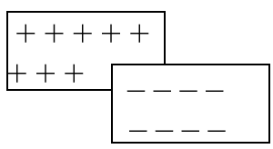 Consider two oppositely charged parallel plates as shown above The potential of a positively charged object is an indication of how much work will have to be done to bring another positively charged object up to it. Therefore the more positive charge that is on the object, the greater its potential will be. If however we bring a negatively charged object up close to the positively charged object, their electricity fields will tend to cancel each other out, and it will then become easier to bring more positive charge up to the original – positively charged – object. This means that the potential of the original object becomes reduced simply by bringing an oppositely charged conductor up close to it. This is the principle upon which a parallel plate capacitor is based. The key is to remember that the more their electric fields cancel each other out, the greater will be the capacitance of the system. The capacitance will increase if the common area between plates (A) increases, or if the distance between plates (d) decreases. Therefore C ∝ A and C ∝ $\frac{1}{d}$ ⇒ C ∝ $\frac{A}{d}$ ⇒ C = k $\frac{A}{d}$ The proportional constant turns out to be ε (remember we came across this in the last chapter as part of Coulomb’s Law) and represents the permittivity of the medium between the two plates.
To demonstrate the factors affecting the capacitance of a parallel plate capacitor An alternative demonstration involves using a gold leaf electroscope instead of a capacitance meter, but it’s a bit trickier to understand what’s going on in that case so we’ll stick with the simpler approach as outlined here. The demonstration described here is perfectly adequate and is much more straightforward.
You don’t need to know anything about the permittivity of different materials other than air is the lowest.
Tuning a radio or television involves selecting a particular transmission frequency from all the incoming frequencies. This can be achieved by varying the capacitance of the detecting circuit. How does this work? Well, the larger the size of the capacitor, the longer it takes to discharge (and charge). Now if the time it takes to charge and discharge corresponds to the frequency of the alternating current – which in turn is carrying the sound information from the radio station – then this signal will amplified and fed through to the radio’s speakers.
In diagram B above (direct current) once the circuit is complete there is a sudden movement of electrons, but because the circuit is not complete (there is a gap between the capacitor plates) there is no further flow. In the diagram A the plates are continuously charging and discharging; the time this takes (and therefore the frequency) depends upon the size of the plates (see previous point). Strictly speaking the current is not ‘passing through’ the capacitor, but merely acts as though it is. For what it’s worth, the separation of charge in a thundercloud (see the piece on lightning in the previous chapter) means that the thundercloud itself is a capacitor (but note that this does not qualify as an ‘application’ of a capacitor. Can you say why?

